Tenda AC5-how to configure router?
Model Number: Tenda AC5
Question Classification: Function Setting

Step 1:Plug ethernet cable into WAN port. Connect PC with LAN port or use PC or mobile device to connect router WiFi signal.

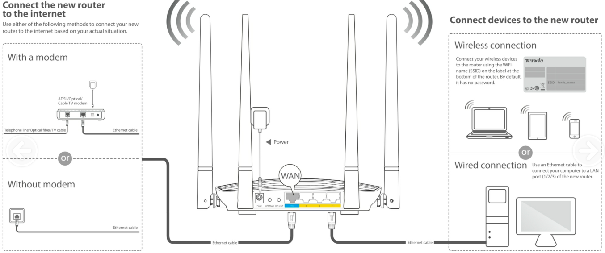

Step 2: Open a browser and type tendawifi.com in Address Bar, tap “Enter”. Tap “Start”.

Case 1：If your connection type is PPPoE. Please enter “ISP User Name” and “ISP Password”
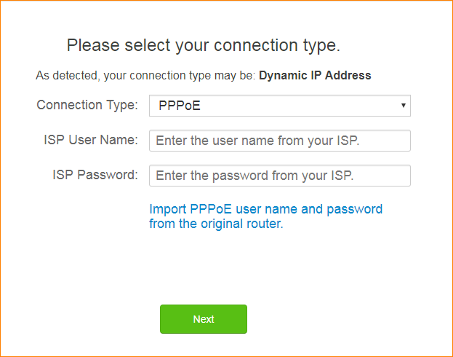

Case 2：If your connection type is Dynamic IP Address. Please tap “Next”.
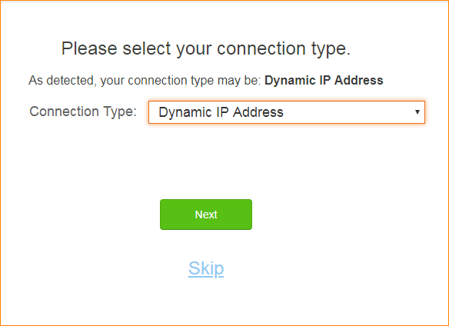

Case 3: If your connection type is Static IP Address. Please enter the information. And tap “Next”.
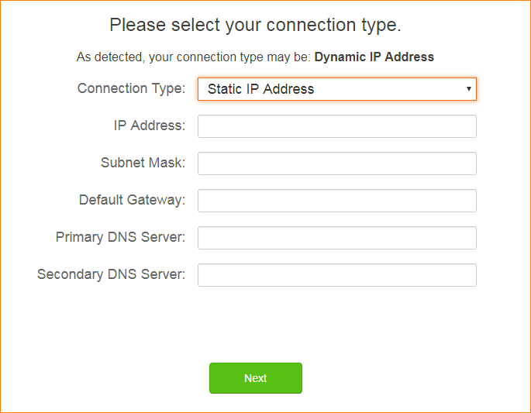

Step 3: Set up WiFi Name and WiFi password.
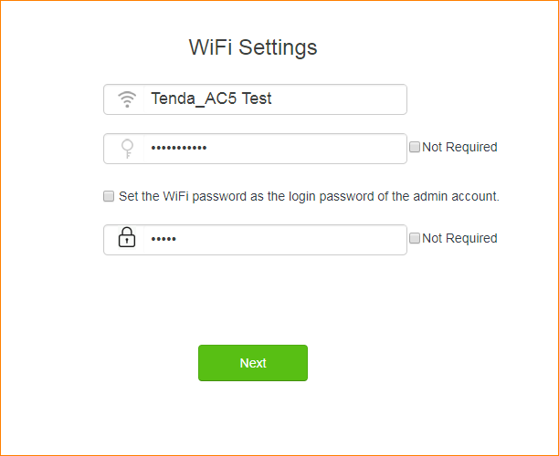

Step 4: Wait for few seconds, Setting is successful when picture shows as below.

Step 5: Refresh the web page and it will skip to login page. Enter the login password.

Check Internet Status.

